
School of Computer Science Engineering and Information Systems

(SCORE)
Winter Semester 2025-2026
Assessment-01

Name: DHAYALAKSHMI A
Reg. No: 24MIS0158
Faculty Name: Dr Gunasekaran G
Course Code: ISWE207P
Course Name: Object Oriented Analysis and Design Lab
Lab Slot: L39+L40

Problem Statement 01: Recipe Manager Software System (RMSS)
Build an app that allows users to add, edit, delete, and view their own recipes added by other users. Users can view recipes added by other users and give comments on their posts. For recipes, users can view Images and videos of recipes.
Building this application can help users understand data structure concepts such as LinkedList, Arrays, HashMap, and Array Lists along with CRUD operations.
Storing and retrieving recipe data helps developers in making network API calls. The following features should have in Recipe Manager software system as given below.
- Add recipes with ingredients and other details such as images and photos
- Categories recipes list with category-wise
- Search recipes with names or ingredients
- Edit and delete existing recipes
- Ability to rate, review, and share recipes

EXPERIMENT-1
SOFTWARE REQUIREMENT SPECIFICATION
AIM: The aim of the experiment is to prepare a Software Requirements Specification for the project recipe manager software system.
- Introduction
  - Purpose:
The purpose of this software Requirement Specification(SRS) document is to provide a clear and detailed description of the requirements for the Recipe Manager Software System[RMSS].This document explains the system’s functionality, requirements, and constraints. It serves as a formal guide during development and testing and also helps faculty members understand the scope and intent of the project. This SRS mainly focuses on defining what the system should do rather than how it will be implemented.
1.2 Document Conventions:
This document is written using simple and clear language so that it can be easily understood by both technical and non-technical readers. Standard section numbering is followed for clarity. Important requirements are written using clear statements to avoid confusion. No special symbols or formatting styles are used, and all requirements are considered equally important unless stated otherwise.
1.3 Intended Audience and Reading Suggestions:
This document is intended for multiple audiences. Developers can use this document to understand the system requirements before implementation. Testers can refer to it to validate system behavior. Faculty evaluators can use it for academic assessment, and users can get an idea of what the system offers. Readers are advised to go through the Introduction and Overall Description sections first to understand the system at a high level, followed by System Features and Nonfunctional Requirements for detailed information.
1.4 Project Scope:
The Recipe Manager Software System is an application that helps users efficiently manage their cooking recipes in a digital format. Instead of maintaining recipes on paper or scattered notes, user can store all their recipes in one place. The system allows users to add, update, delete, search and view recipes based on the different criteria such as recipe name, ingredients, or category. The application is suitable for home cooks, students, and small food businesses.
1.5 Reference:
This document is prepared based on OOAD laboratory guidelines and standard SRS documentation format
1.6 Definition, Acronyms and Abbreviations:
UI – User Interface
DB – Database
CRUD – Create, Read, Update and Delete
UML-Unified Modeling Language.
.
- Overall Description

2.1 Product Perspective:
The Recipe Manager Software System is designed as a standalone application that helps users organize and manage their cooking recipes digitally. Traditionally, recipes are written in notebooks or stored across different platforms, which can be difficult to maintain. This system provides a centralized and structured way to store a recipes in one place. This application can be developed either as a desktop-based or web-based system depending or requirements.
2.2 Product Features:
The major features provided by the system include:
- Adding and storing recipes digitally
- Editing and deleting existing recipes
- Searching recipes using name or category
- Viewing detailed recipe instructions
These features help users manage their recipes in a simple and efficient way.
2.3 User Classes and Characteristics:
The system is mainly intended for general users such as students, home cooks, and small food business owners. Users are expected to have basic knowledge of using a computer or smartphone. Since the system is designed to be user-friendly, no technical background or training is required.
2.4 Operating Environment:
The system can run on common operating systems such as Windows, Linux, and macOS. It can be implemented as a desktop or web-based application and accessed using laptops, desktops, tablets, or smartphones.
2.5 Design and Implementation Constraints:
The performance of the system depends on the hardware and database used. For web-based implementation, internet connectivity is required. Security measures must be followed to protect user data stored in the database
2.6 User Documentation:
Basic user documentation such as a user manual and help instructions will be provided to assist users in using the system features properly.
2.7 Assumptions and Dependencies:
It is assumed that users will enter correct and meaningful recipe data. The system depends on proper functioning of the database and operating system. Any issues in these components may affect system performance.
3.System Features
This section describes the main system features of the Recipe Manager Software System. Each feature explains what the system does and how it responds to user actions.
3.1 System Feature 1: User Authentication
3.1.1 Description and Priority:
This feature allows users to log in to the system using their credentials. Authentication ensures that only authorized users can access and manage their recipes. This feature is considered High Priority because it protects user data and ensures privacy.
3.1.2 Stimulus / Response Sequences:
- The user enters a username and password.
- The system verifies the entered details.
- If the credentials are valid, the system grants access to the user.
- If the credentials are incorrect, an error message is displayed.
3.1.3 Functional Requirements:
REQ-1: The system must allow users to enter login credentials.
REQ-2: The system must validate user credentials before granting access.
REQ-3: The system must display an error message for invalid login attempts.
3.2 System Feature 2: Recipe Search
3.2.1 Description and Priority:
This feature allows users to search for recipes using keywords or categories. It is considered a Medium Priority feature as it improves usability and saves time for users.
3.2.2 Stimulus / Response Sequences:
- The user enters a search keyword.
- The system searches the stored recipes.
- Matching recipes are displayed to the user.
3.2.3 Functional Requirements:
REQ-4: The system must allow users to search recipes by name.
REQ-5: The system must display all matching search results clearly.

4. External Interface Requirements
This section explains how the Recipe Manager Software System interacts with users and other systems.
4.1 User Interfaces:
The system provides a simple and user-friendly interface that allow users to log in, manage recipes,and search for recipes easily. All screen are designed to be clear and easy to understand.
4.2 Hardware Interfaces:
The system does not requires any special hardware. Users can access the system using standard devices such as Camera and storage access are needed for uploading media files.
4.3 Software Interfaces:
The system interact with a database and authentication module for data storage and user verification.
4.4 Communication Interfaces:
For web- based operation,the system used standard protocols such as HTTP or HTTPS for Secure data communication .
5. Other Nonfunctional Requirements
This section explains the nonfunctional requirements of the Recipe Manager Software System. These requirements describe how well the system should work rather than what functions it performs. They focus on important quality aspects such as performance, safety, security, and overall software quality.
5.1 Performance Requirements
The Recipe Manager Software System should work efficiently under normal usage conditions. The system is expected to respond quickly when users perform actions such as logging in, adding recipes, searching for recipes, or viewing saved data.
- The system should load screens and user interfaces within 2 seconds under normal network and hardware conditions.
- The system should be capable of storing and managing at least 1000 recipes per user without noticeable slowdown.
- Database operations like saving, updating, and retrieving recipes should be completed smoothly and without delay.
- These performance requirements help ensure a fast and user-friendly experience
5.2 Safety Requirements
The Recipe Manager Software System does not involve physical equipment or hazardous operations. As a result, there are no direct safety risks related to its usage. However, the system should still protect users from accidental data loss.
- The system should display confirmation messages before deleting any recipe.
- Backup or recovery options should be available to prevent permanent loss of user data.
These precautions help ensure that user information is handled safely.
5.3 Security Requirements
Security is an important aspect of the system since it stores personal user details and private recipe information. The system must ensure that all user data is protected from unauthorized access.
- The system must require valid user authentication using a username and password.
- Users should only be able to access their own recipes and personal data.
- Passwords must be stored securely in the database using encryption or hashing methods.
- Any unauthorized access attempts should be restricted by the system.
- These security measures help maintain user privacy and data confidentiality.
5.4 Software Quality Attributes
The Recipe Manager Software System should meet standard software quality expectations to ensure reliability and long-term usability.
- Usability: The system should be simple and easy to use, even for new users, with clear navigation and instructions.
- Reliability: The system should function correctly during regular use without frequent crashes or failures.
- Maintainability: The software should be easy to maintain and update without affecting existing features.
- Scalability: The system should support future enhancements and an increase in the number of users.
- Portability: The system should be able to run on different platforms such as desktop and mobile devices
6. Other Requirements
- This section includes additional requirements that are important but not covered in earlier sections of the SRS.
- The system should use a well-structured database to maintain data consistency and integrity.
- The software should allow future improvements such as recipe sharing, ratings, or cloud-based storage.
- The system should follow standard software engineering practices and development guidelines.
RESULT:
The Software Requirements Specification for the project recipe manager software system has been analyzed and documented successfully.

EXPERIMENT-2
USE CASE MODELING: Recipe Manager Software System (RMSS)
AIM: The aim of the experiment is to Identify actors involved in recipe manager software system, draw use case model and describe scenarios using use case template for the project.
  - ACTORS:
The actors involved in the Recipe Manager Software System are:
1.User:
The user is the main person who uses the recipe manager application. The user can add new recipes,search for recipes, view recipe details, edit recipes, delete recipes .
2.Admin:
The admin manages the system.the admin is responsible for managing users and deleting unwanted or incorrect recipes from the system.

  - USE CASE:
Scenario  Starts when | Actor | Trace | Action | Output
Scenario  Starts when | User | Login | Users enters valid login credentials. | Login  Successful
Scenario  Starts when | User | search  Recipe | Users searches for recipes by name. | Recipe list displayed.
Scenario  Starts when | User | View Recipe | User selects a recipe from the list. | Recipe details displayed.
Scenario  Starts when | User | Add  Recipe | User enters recipe details. | Recipe submitted successfully.
Scenario  Starts when | Admin | Approve  Recipe | Admin review and approve recipe | Recipe published.
Ends | User Logout Users logs out Session ended

  - USE CASE MODEL
        - The Use Case Model shows how different actors interact with the Recipe Manager Software System.
        - The system supports two actors namely User and Admin.
        - Users can create and manage their own recipes. Users can view, search, rate and review recipes shared by others.
        - The admin monitors system activities and manages users and recipes.
        - This model helps in understanding the functional flow of the system clearly.

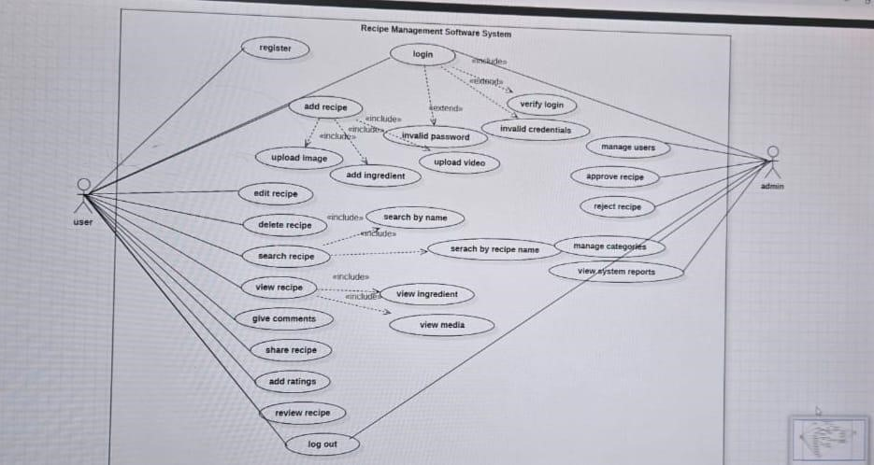

2.4 USE CASE DOCUMENT
    - Name: Add Recipe
    - Brief Description:
This use case describes the process by which a registered user adds a new recipe to the Recipe Management Software System. The recipe is reviewed by the admin before it is approved and made available to other users.
    - Actors:
      - User
      - Admin
    - Preconditions:
      - The user must be registered and logged into the system.
      - The system must be operational
    - Basic Flow:
      - The user logs into the system using valid credential.
      - The user selects the Add Recipe option and enters the recipe details, including ingredients and media files.
      - The system validates the entered information and submits the recipe for admin review.
      - The admin reviews the recipe and approves it.
      - The system publishes the approved recipe for other users to view.
    - Alternate Flows:
      - If the user decides to save the recipe as a draft, the system stores the recipe without submitting it for admin approval.
      - If the admin requests minor modifications instead of rejecting the recipe, the system notifies the user to update the recipe and resubmit it for approval.
    - Exception Flows:
      - If the user enters incomplete or invalid recipe details, the system displays an error message and requests correction.
      - If media upload fails due to format or size issues, the system asks the user to re-upload valid files
      - If the admin rejects the recipe during review, the system notifies the user and the recipe is not published.
    - Post Conditions:
        - The recipe is successfully stored in the system after approval.
        - The user receives confirmation regarding the recipe status.
RESULT:
Thus, the use case diagram and documentation for the recipe manager software system designed using StarUML software, has been successfully completed.

EXPERIMENT-3
AIM: To identify the entity class, boundary class, control class relationships, attributes, operations and draw class diagram for the project recipe manager software system.
3.1 Identify the Classes
- Entity Classes
    - User
    - Recipe
    - Category
    - Review
    - Media
- Boundary Classes
    - LoginUI
    - RecipeUI
    - AdminUI
- Control Classes
    - ShareManager
    - SearchManager
  - Define Attributes:
User
    - userId:int
    - userName :string • email : string
    - password : string Recipe
    - recipeId : int
    - recipeName : String
    - ingredients:String
    - instruction : String
    - rating : float Category
    - categoryId : int
    - categoryName : String
    - description : String
    - recipeList : String
Review
    - reviewId : int
    - userId : int
    - recipeId : int
    - rating : float
    - comments : String Media
    - mediaId : int
    - recipeId : int
    - mediaType : String
ShareManager
    - shareId : int
    - userId : int
    - recipeId : int
    - platform : String
    - shareLink : String
SearchManager
    - recipeList : String
    - ingredientList : String
    - searchResult : String

  - Define Methods
1.User
      - register()
      - login()
      - addRecipe()
      - editRecipe()
      - deleteRecipe()
2.Recipe
      - addRecipe()
      - updateRecipe()
      - deleteRecipe()
      - viewRecipe()
      - calculateRating()
3.Category
      - addCategory()
      - updateCategory()
      - deleteCategory()
      - addRecipe()
      - viewRecipe()
Review
      - addReview()
      - updateReview()
      - deleteReview()
      - viewReview()
      - approveReview()
5.Media
      - uploadImage()
      - uploadVideo()
      - deleteMedia()
      - updateMedia()
      - viewMedia()
6.ShareManager
      - shareRecipe()
      - generateLink()
      - trackShare()
      - deleteShare()
7.SearchManager
      - searchByName()
      - searchByIngredient()
      - searchByCategory()
      - displayResults()
      - clearSearch()

  - Identify Relationships:
    - A User can create multiple Recipes (One-to-Many)
    - A Recipe can contain multiple Ingredients (One-to-Many) o Many reviews are written for one recipe.(Many-to-One) o One recipe can have multiple media files(One-to-Many). o One category contains many recipes(One-to-Many). o A user can share multiple recipes(One-to-Many). o A recipe can be shared multiple times(One-to-Many). o Search Manager accesses recipe data
  - Draw the Class Diagram The class diagram includes:
    - Entity classes: User, Recipe, Category, Review, Media o Boundary classes: LoginUI, RecipeUI, AdminUI o Control classes: ShareManager,SearchManager.

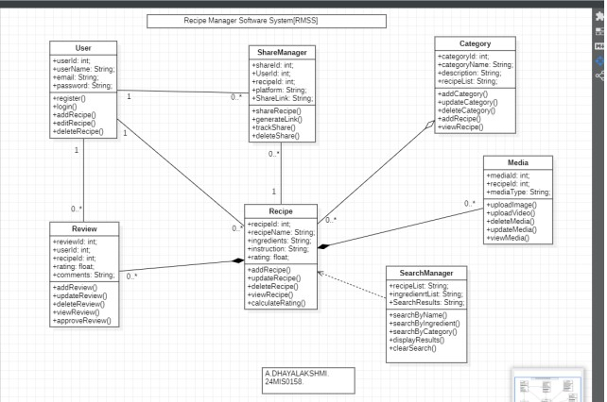

RESULT:
Thus, the class diagram for the recipe manager software system was successfully designed using StarUML by identifying classes, attributes, methods, and relationships.

